Amazon Machine Learning

Endpoint Url: <https://realtime.machinelearning.us-east-1.amazonaws.com>

Open the S3 and go to create model

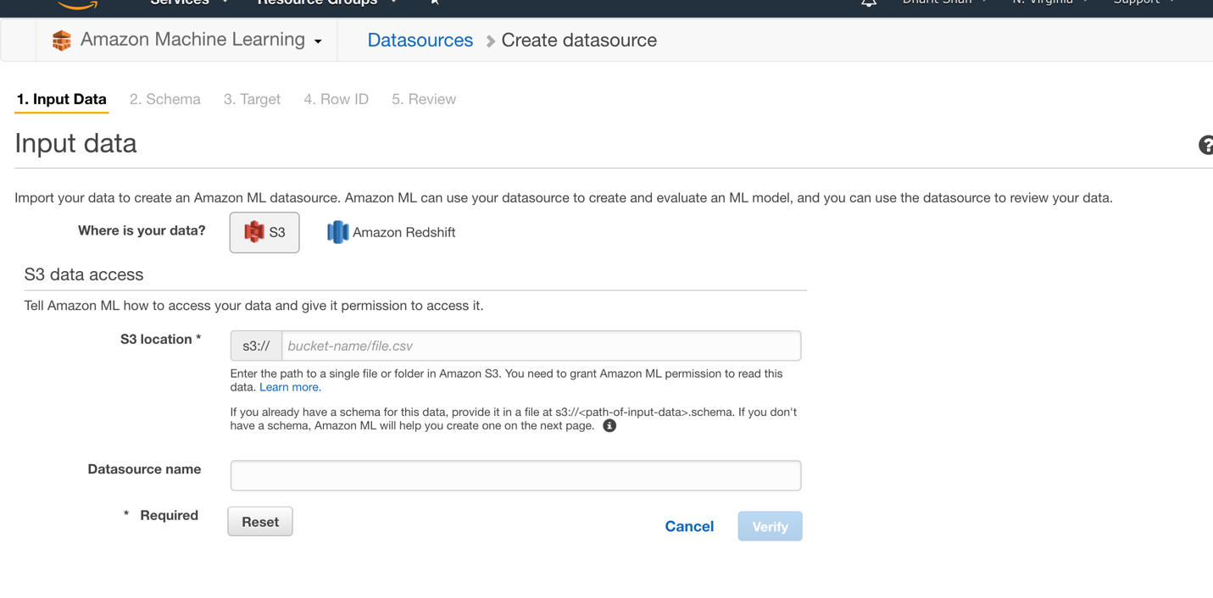

After Creating Model You have to select Identifier and on which column you want to perform prediction

After Creating that Amazon Machine Learning will automatically select which algorithm to perform

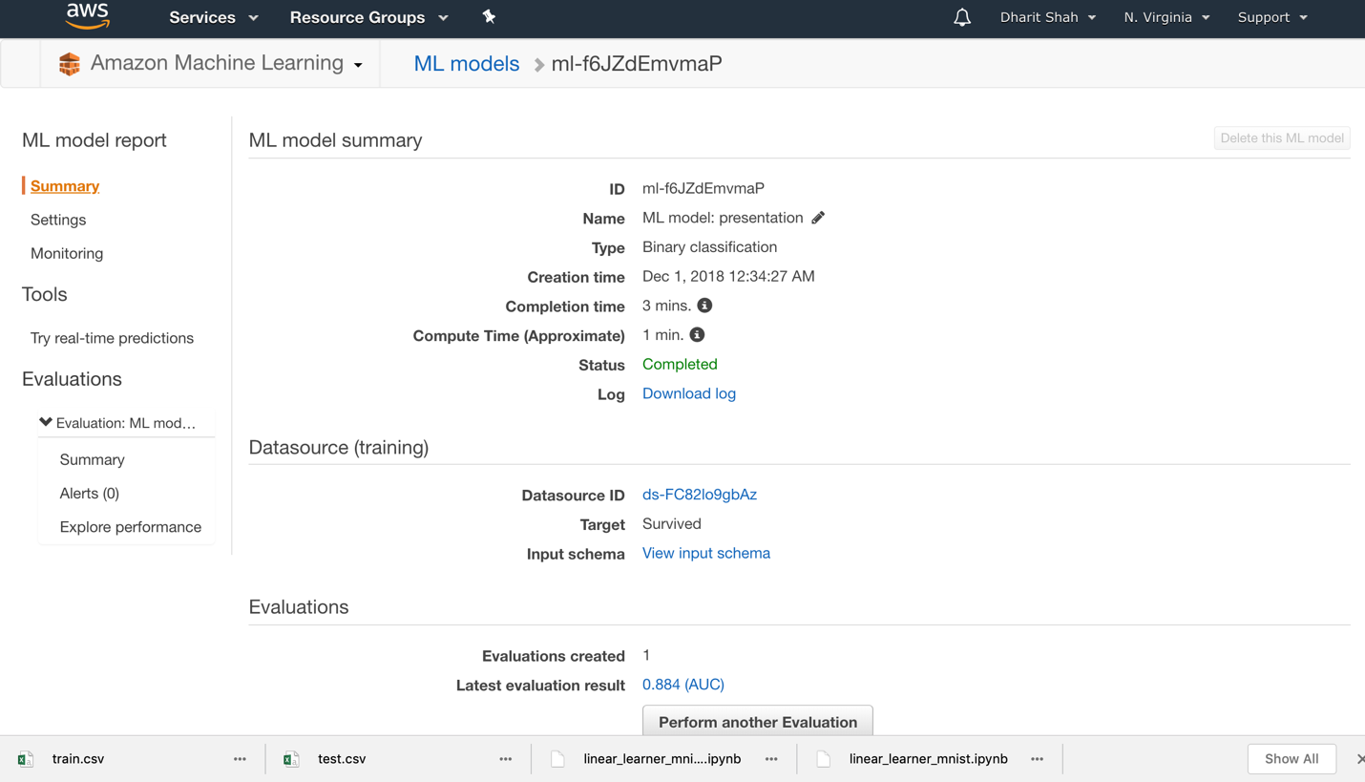

Summary

